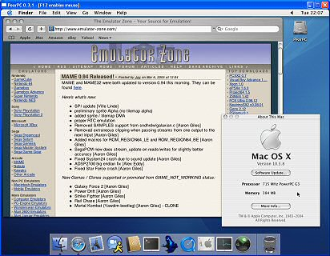
PearPC emulates a PowerPC like CPU similar to an G3. This is the same CPU used in older Apple hardware such as the first model iMac. Apart from being able to emulate various Unix OS for PowerPC, PearPC can also emulate Apple Mac OS X even up to the latest version (v10.4, aka Tiger).
Please don't expect it to run extremely smooth. The development team themself admit the emulator runs about 15 times slower than the host PC. So with a Pentium IV 2.4 Ghz, the emulated G3 CPU inside PearPC will feel like it's running at 240 Mhz. That's fast enough to try Mac OS, but don't think about running something like Final Cut Pro (professional video editing software) on it.
Network emulation (as demonstrated by the screenshot) is supported (albeit a bit tricky to get running) but no sound emulation or support for other exotic hardware. All in all, if you want to see what Mac OS X is like this emulator is for you, otherwise a Mac mini ($500) may be a better choice.
While several of the necessary support files and setup guides can be found on the main site, you may also find the site PearPC.net a useful resource. Be sure to check the links section of that site for links to sites with the latest builds, which may be more buggy but faster.

